Genuine Device Detection Subsystem 1.0.0

User Guide (Public User)

GDDS-User-Guide-Public-1.0.0

November 23, 2020

Revision history

|  |  |  |
| --- | --- | --- |
| Revision | Date | Description |
| A | November 2020 | First Release |

# Contents

1. Introduction 4

1.1. Purpose 4

1.2. Supported Desktop Browsers 4

1.3. Supported Mobile Browsers 5

1.4. Definitions, Acronyms, and Abbreviations 5

2. System Description 6

3. System Navigation 7

3.1. Portal Sections 7

3.2. Home Page 8

**Figures**

Figure 1 - Portal Sections 7

Figure 2 - Home Page 8

Figure 3 - Confirmation Message 9

**Tables**

Table 1 - Supported Desktop Browsers 4

Table 2 - Supported Mobile Browsers 5

Table 3 - Definition, Acronyms, and Abbreviations 5

Table 4 - System Description 6

# **Introduction**

Genuine Device Detection Subsystem (GDDS) is the subsystem of Device Identification, Registration & Blocking System (DIRBS). It provides a platform for Public User to respond with requested device information i.e. Serial Number, Color, Brand, and Model Name against a unique identifier which was received earlier via SMS for proving the legitimacy of the device.

The Device Identification, Registration & Blocking System (DIRBS) is a country-wide system deployed in cooperation between the country regulator, operators in that country, and a technology partner that supports deployment. The system checks, identifies, and discourages non-compliant devices by verifying the installed base of devices currently active in a market and continuing to monitor as new devices are activated.

DIRBS can verify that:

* Devices have properly allocated identifiers and type approval
* Devices are not duplicated or stolen
* Device importation takes place through legal channels

# **Purpose**

This document is intended to give assistance to the user to use the Genuine Device Detection Subsystem (GDDS).

# **Supported Desktop Browsers**

Table 1 - Supported Desktop Browsers

|  |  |
| --- | --- |
| **Name** | **Version** |
| Internet Explorer | 11.0 |
| Firefox | 82.0.3 |
| Chrome | 86.0 |
| Safari | 13.1.2 |
| Edge | 86.0 |

# **Supported Mobile Browsers**

Table 2 - Supported Mobile Browsers

|  |  |
| --- | --- |
| **Name** | **Version** |
| Chrome | 86.0.4 |
| UC Browser | 13.3.3 |
| Opera (Android) | 60.3 |
| Opera Touch (iOS) | 2.5.1 |
| Safari | 13.1.2 |
| Samsung Internet | 13.0.1 |
| Android | 10 |

# **Definitions, Acronyms, and Abbreviations**

Table 3 - Definition, Acronyms, and Abbreviations

|  |  |
| --- | --- |
| **Term** | **Definition** |
| **DIRBS** | **Device Identification Registration and Blocking System** |
| GDDS | Genuine Device Detection Subsystem |
| UID | Unique Identity |
| IMEI | International Mobile Equipment Identity |

# 

# **System Description**

Table 4 - System Description

|  |  |
| --- | --- |
| Feature/Sections | ****Explanation**** |
| Portal Sections | The portal is divided into the following sections.   * **Header**   **Header section displays name of the system.**   * **Main Content Area**   Main Content Area contains all the content to be displayed and actions to be performed.   * **Footer**   Footer contains the software version and copyrights statement. |
| OEM Home Page | * Home Page displays fields for requested information where user has to mention required information of the device i.e. IMEI, Unique ID, Serial number, Color, Brand, Model Name, MAC address and RAT. |

# **System Navigation**

# **Portal Sections**

The portal screen is divided into following sections.

1. **Header** section displays name of the system.
2. **Main Content Area** contains all relevant information related to the respective feature/option.
3. **Footer** contains version and copyrights of the system.

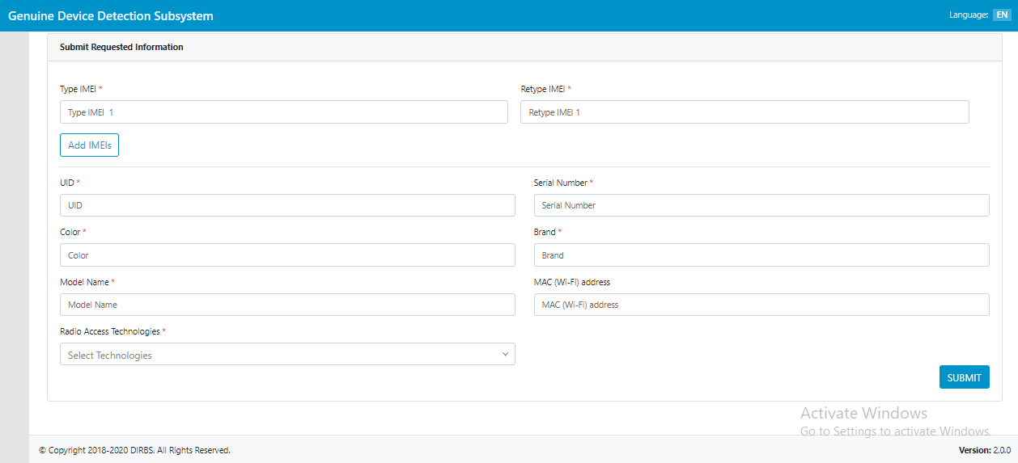

Figure 1 - Portal Sections

# 

# **Home Page**

Home Page screen displays fields where user has to enter requested information of the device.

1. Enter IMEI of the device.
2. Re-enter IMEI of the device.
3. Click on “Add IMEI” button to enter more IMEIs (if device has more than one IMEI).
4. Enter unique ID, which has been received via SMS.
5. Enter serial number of the device.
6. Enter color of the device.
7. Enter brand of the device.
8. Enter model name of the device.
9. Enter MAC (Wi-Fi) address of the device.
10. Enter RAT of the device.
11. Click on “Submit” button to save the entered information.

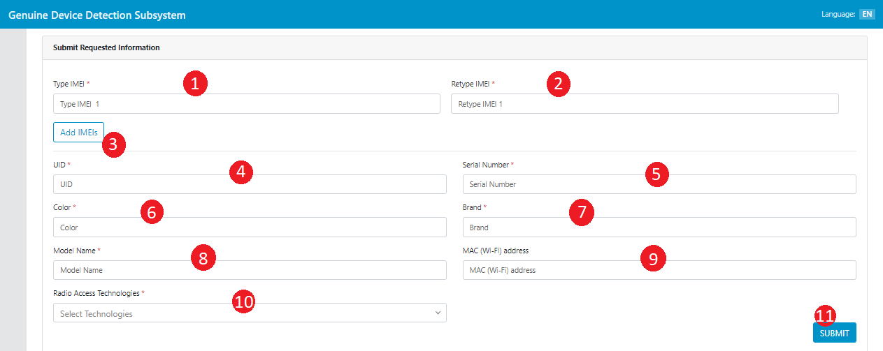

Figure 2 - Home Page

A confirmation message will pop up on screen. Click on “Ok” button to proceed.

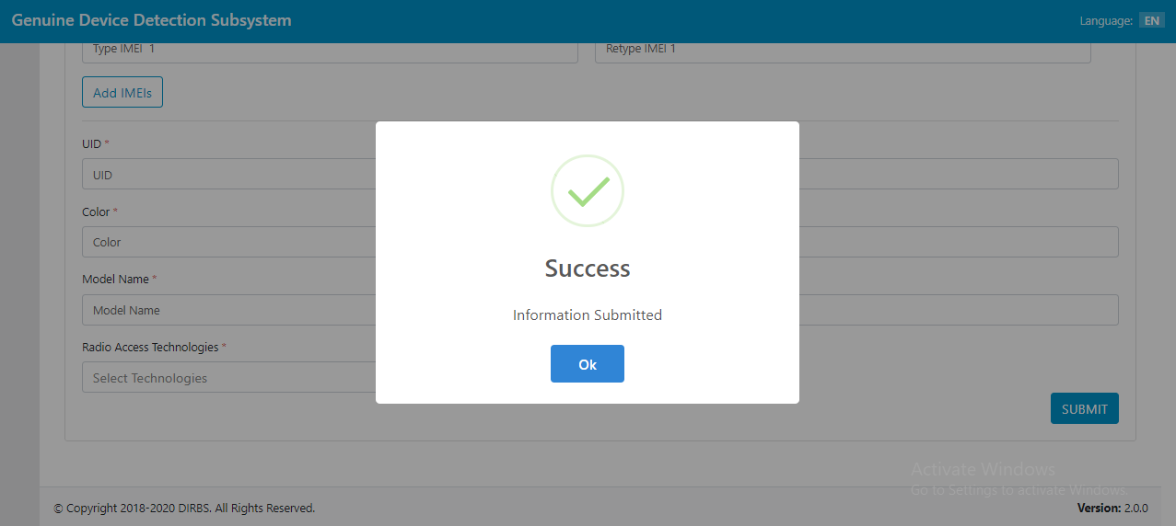

Figure 3 - Confirmation Message